Parking Reservation and Availability Management
The ParkaLot parking reservation prototype is aimed at providing the platform with a convenient and easy-to-use interface, where a customer can easily check parking availability and provide reservation information. The major objective of this item is to emulate the interaction of end-users with the system in a real-life situation, in such a way that the interface is user friendly, quickly responsive, and in accordance with the current usability ideals. Based on the issues found in the case study, specifically the absence of real-time visibility and intermittent customer experience, the prototype will focus on providing a systematic and uniform means of parking reservation in all the garages.
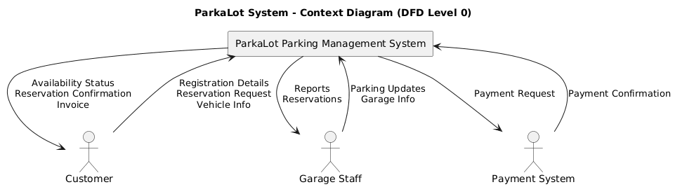
The interface will be implemented with a minimalistic and clean layout so that it becomes easier to use and access. The user is presented with a centralised form into which they enter all the required reservation details in a logical order. A pleasing gradient background and a card-based container make the interface look modern and professional and at the same time attract the user to the main functionality of the system. The design has been well planned in such a way that it minimizes cognitive load so that the user can accomplish their task without being bogged down in details or too much complexity. Labels are well defined, there is proper spacing between input fields and the design itself is presented in a consistent visual hierarchy.
One of the important features of the prototype is the gathering of the necessary reservation information. The system will ask the user to enter the date of parking, number of vehicles, vehicle registration number, arrival time, departure time and vehicle type. These inputs are essential in deciding the availability of parking space and in making sure that the system is able to distribute resources in an efficient way. Through this arrangement of the form, the prototype would be an indication of the real world situation where there is a need to have correct and full information in order to process reservation. The addition of the type of vehicle options, including Sedan and SUV, also contributes to the differentiation of the system in terms of the space needs and efficient parking allocation.
Validations are also integrated in the prototype to facilitate completeness and reliability of data. All fields must be filled in before proceeding hence the chances of making incomplete or incorrect reservations are minimal. The given approach follows the best practice in the field of user interface design, as early validation facilitates error prevention and improves the overall user experience. The system enhances efficiency and minimizes the corrective measures required at a later stage by directing users to give all the required information at the start-up.
The other significant attribute of the prototype is that it gives a real-time feedback to the user once he or she gives his or her details. After the information needed has been typed, the system shows a response that shows the availability of a parking position or otherwise. This is an urgent reaction in response to one of the key weaknesses that have been found in the existing ParkaLot processes, in which customers do not have any visibility regarding parking spots. The feedback is also displayed in a clear and visually different way, with colour coded indicators to show the available and unavailable states. This improves the user comprehension and makes the information communication effective.
Besides the availability status, the prototype also includes a summary of the reservation details, such as the number of vehicles, vehicle registration number, chosen time slot, and the type of vehicle. This summary will act as a reassurance to the user and they are able to check what they have entered and continue with a complete system implementation. This is critical in the effort to instill confidence in the users, and in making the reservation process transparent. It is also indicative of the manner in which the final system would provide booking confirmations to customers in organized and informative manner.
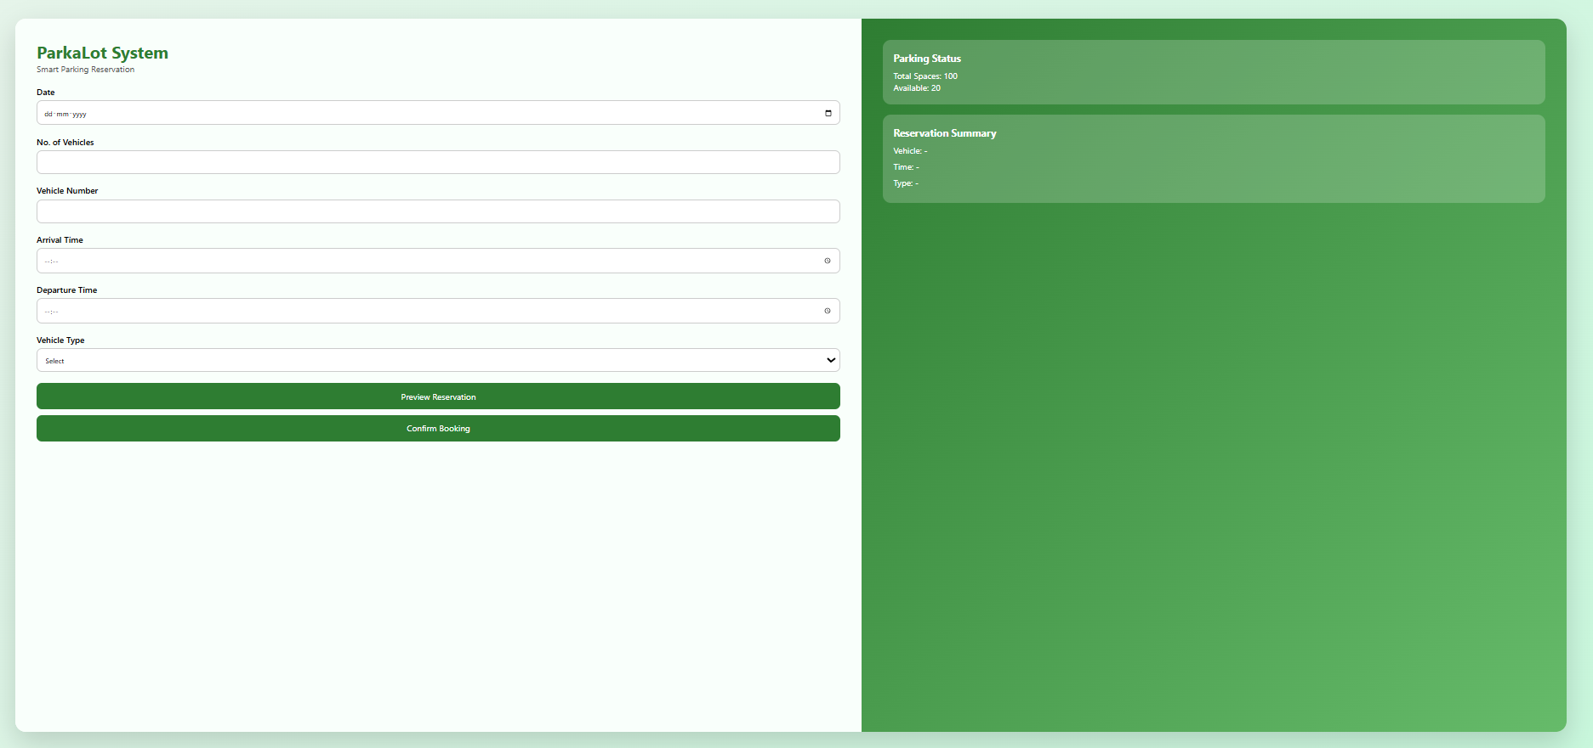
Responsiveness and flexibility in various devices are also considered in the design of the interface. Even though the prototype itself is mainly shown on a desktop interface, the layout is designed in such a manner that it can readily be used on mobile and tablets. This is especially necessary considering the growing dependency on mobile to access services. Responsive design guarantees that the users can communicate with the system in the same way, no matter what device they are on, thus improving accessibility and user satisfaction.
<!DOCTYPE html>
<html lang="en">
<head>
<meta charset="UTF-8">
<title>ParkaLot - Smart Reservation</title>
<meta name="viewport" content="width=device-width, initial-scale=1.0">

<style>
*{
margin:0;
padding:0;
box-sizing:border-box;
font-family:'Segoe UI',sans-serif;
}

body{
background:linear-gradient(135deg,#e6f4ea,#c8f7dc);
min-height:100vh;
display:flex;
align-items:center;
justify-content:center;
}

.wrapper{
width:95%;
height:92vh;
background:white;
border-radius:20px;
box-shadow:0 20px 50px rgba(0,0,0,0.15);
display:grid;
grid-template-columns:1.2fr 1fr;
overflow:hidden;
}

/* LEFT */
.left{
padding:40px;
background:#f9fffb;
}

h1{
color:#2e7d32;
}

.subtitle{
margin-bottom:20px;
color:#555;
}

label{
font-weight:600;
margin-top:10px;
display:block;
}

input,select{
width:100%;
padding:12px;
margin-top:5px;
border-radius:10px;
border:1px solid #ccc;
margin-bottom:10px;
}

button{
width:100%;
padding:14px;
margin-top:10px;
border:none;
border-radius:10px;
background:#2e7d32;
color:white;
font-size:16px;
cursor:pointer;
}

button:hover{
background:#1b5e20;
}

.preview,.result{
margin-top:15px;
padding:12px;
border-radius:10px;
display:none;
}

.preview{
background:#e8f5e9;
color:#2e7d32;
}

.available{
background:#c8e6c9;
color:#1b5e20;
}

.not-available{
background:#ffcdd2;
color:#b71c1c;
}

/* RIGHT */
.right{
padding:40px;
background:linear-gradient(135deg,#2e7d32,#66bb6a);
color:white;
}

.card{
background:rgba(255,255,255,0.2);
padding:20px;
border-radius:15px;
margin-bottom:20px;
}

.card h3{
margin-bottom:10px;
}

.summary p{
margin:8px 0;
}

/* MOBILE */
@media(max-width:900px){
.wrapper{
grid-template-columns:1fr;
height:auto;
}
}
</style>
</head>

<body>

<div class="wrapper">

<!-- LEFT -->
<div class="left">
<h1>ParkaLot System</h1>
<p class="subtitle">Smart Parking Reservation</p>

<label>Date</label>
<input type="date" id="date">

<label>No. of Vehicles</label>
<input type="number" id="vehicles">

<label>Vehicle Number</label>
<input type="text" id="vehicleNumber">

<label>Arrival Time</label>
<input type="time" id="arrival">

<label>Departure Time</label>
<input type="time" id="departure">

<label>Vehicle Type</label>
<select id="type">
<option value="">Select</option>
<option>Sedan</option>
<option>SUV</option>
</select>

<button onclick="previewBooking()">Preview Reservation</button>
<button onclick="confirmBooking()">Confirm Booking</button>

<div id="previewBox" class="preview"></div>
<div id="resultBox" class="result"></div>
</div>

<!-- RIGHT PANEL -->
<div class="right">

<div class="card">
<h3>Parking Status</h3>
<p>Total Spaces: 100</p>
<p id="availableSpaces">Available: 20</p>
</div>

<div class="card summary">
<h3>Reservation Summary</h3>
<p id="sumVehicle">Vehicle: -</p>
<p id="sumTime">Time: -</p>
<p id="sumType">Type: -</p>
</div>

</div>

</div>

<script>
let availableSpaces = 20;

function previewBooking(){
const v=document.getElementById("vehicles").value;
const num=document.getElementById("vehicleNumber").value;
const a=document.getElementById("arrival").value;
const d=document.getElementById("departure").value;
const t=document.getElementById("type").value;

if(!v||!num||!a||!d||!t){
alert("Fill all fields");
return;
}

document.getElementById("previewBox").style.display="block";
document.getElementById("previewBox").innerHTML=
`Preview:<br>
Vehicle: ${num}<br>
Time: ${a} - ${d}<br>
Type: ${t}<br>
Slots: ${v}`;
}

function confirmBooking(){
const v=document.getElementById("vehicles").value;
const num=document.getElementById("vehicleNumber").value;
const a=document.getElementById("arrival").value;
const d=document.getElementById("departure").value;
const t=document.getElementById("type").value;

let result=document.getElementById("resultBox");

if(v<=availableSpaces){
result.style.display="block";
result.className="result available";
result.innerHTML="✅ Parking Available";
availableSpaces-=v;
}else{
result.style.display="block";
result.className="result not-available";
result.innerHTML="❌ Parking Not Available";
}

document.getElementById("availableSpaces").innerText="Available: "+availableSpaces;

document.getElementById("sumVehicle").innerText="Vehicle: "+num;
document.getElementById("sumTime").innerText="Time: "+a+" - "+d;
document.getElementById("sumType").innerText="Type: "+t;
}
</script>

</body>
</html>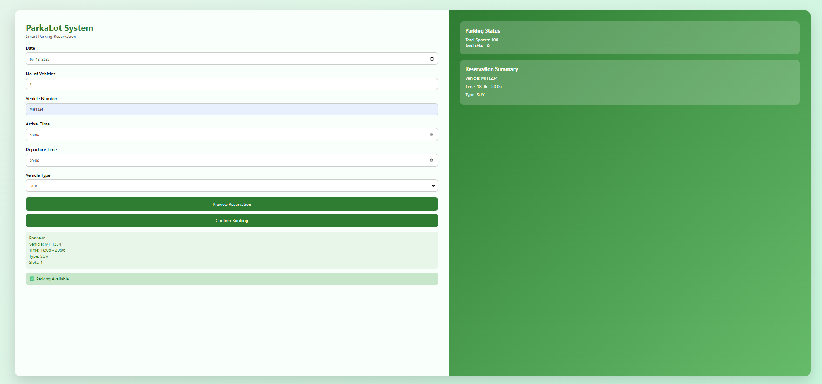
Regarding usability, the prototype is focused on efficiency and simplicity. The flow of interaction is simple and few steps are required to accomplish a task. Unnecessary features and information are not bombarded on the users, particularly in a system that is meant to be used frequently and time-sensitive. The design makes sure that the user can easily check the availability and make a choice, which is a modern trend of digital services.
Moreover, the prototype will assist in the overall goals of the ParkaLot system since it will indicate how a centralised and standardised interface can enhance the customer experience. Unlike the current manual and disparate processes outlined in the case study, this interface offers a steady and stable way of communicating with the system. It eliminates uncertainty, dependency on employees, and gives the user the power to control their parking requirements. This is a major milestone in attaining the objective of digital transformation of the organisation.

